TOPIC 2: BRUTE FORCE
EXP 1: Sorting Lists with Different Cases
AIM: To sort a list under different scenarios such as empty list, single element, identical elements, and negative numbers.
CODE:
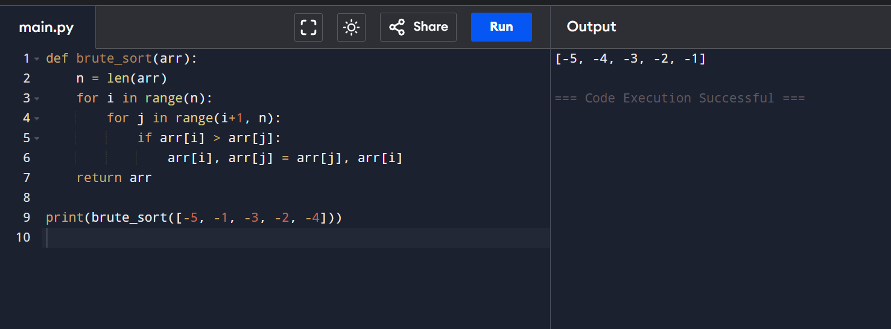
RESULT: The list is sorted correctly for all given cases.
EXP 2: Selection Sort Algorithm

AIM: To sort an array in ascending order using Selection Sort.

CODE:

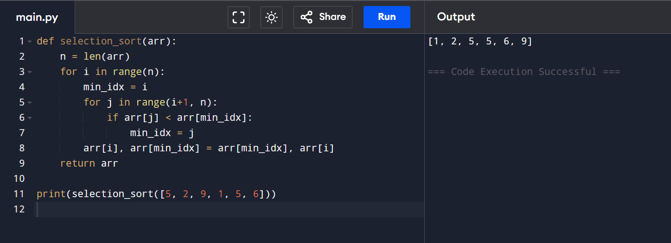

RESULT: The array is sorted successfully using Selection Sort.

EXP 3: Optimized Bubble Sort (Early Stop)

AIM: To optimize Bubble Sort by stopping early if the list becomes sorted.

CODE:

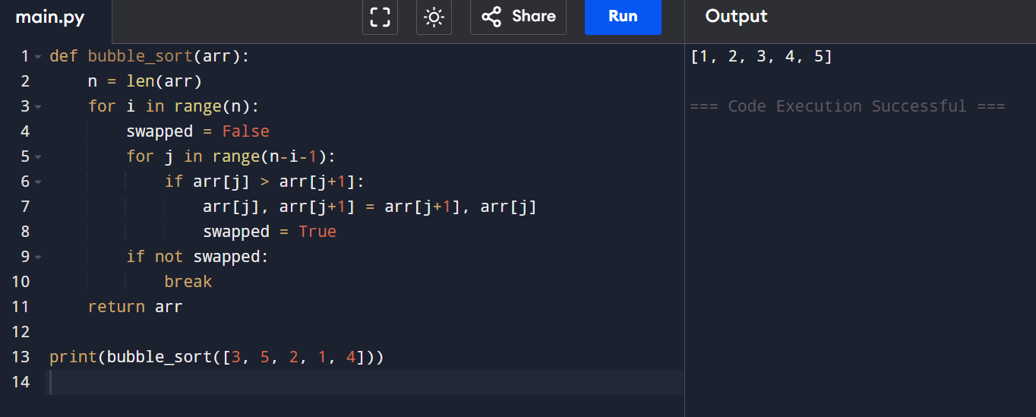

RESULT: The optimized Bubble Sort reduces unnecessary passes.

EXP 4: Insertion Sort with Duplicate Elements

AIM: To sort an array using Insertion Sort while handling duplicate elements.

CODE:

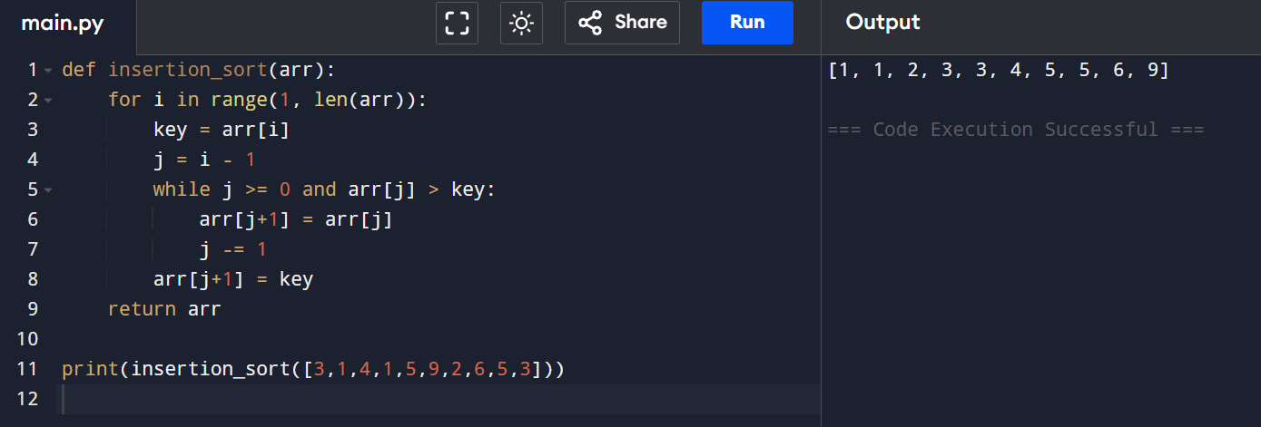

RESULT: Insertion Sort correctly sorts arrays with duplicates.

EXP 5: Kth Missing Positive Number

AIM: To find the kth missing positive integer from a sorted array.

CODE:

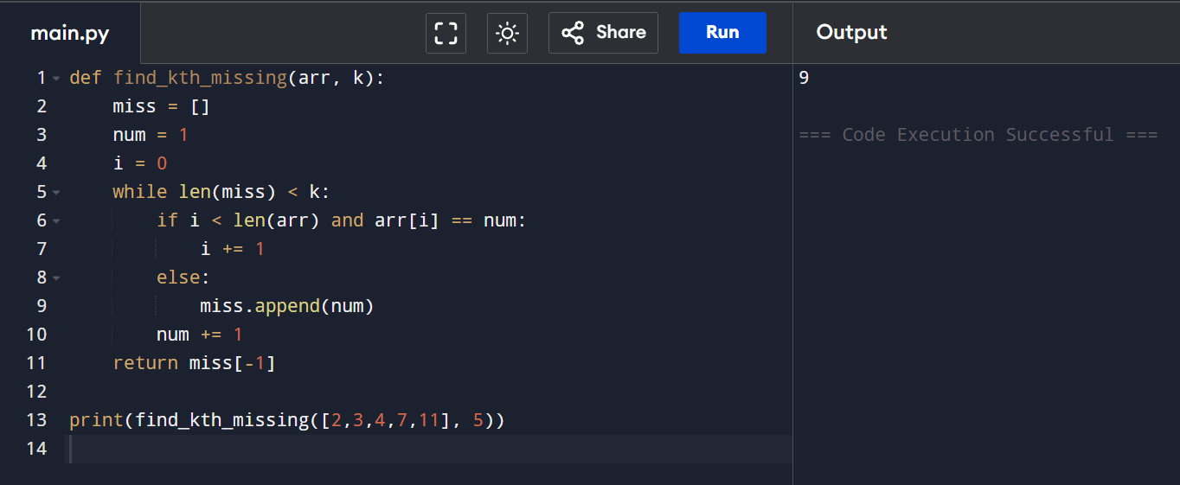

RESULT: The kth missing positive number is found correctly.

EXP 6: Find Peak Element

AIM: To find a peak element index using binary search.

CODE:

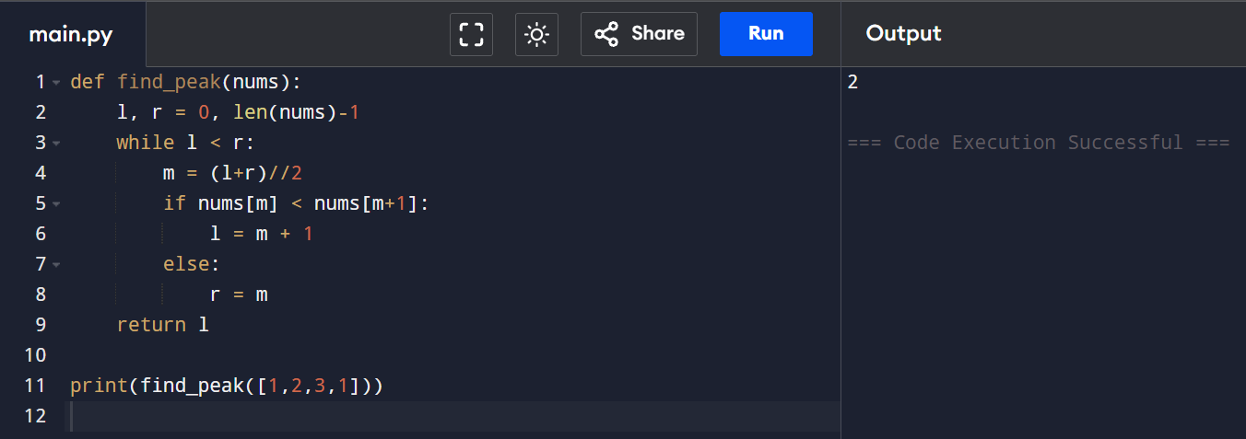

RESULT: A peak element index is found in O(log n) time.

EXP 7: Find First Occurrence of Substring

AIM: To find the index of first occurrence of a substring.

CODE:

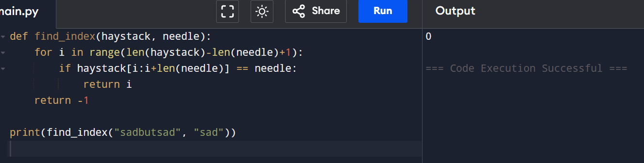

RESULT: The first occurrence index is identified correctly.

EXP 8: Substring Words in an Array

AIM: To find words that are substrings of other words.

CODE:

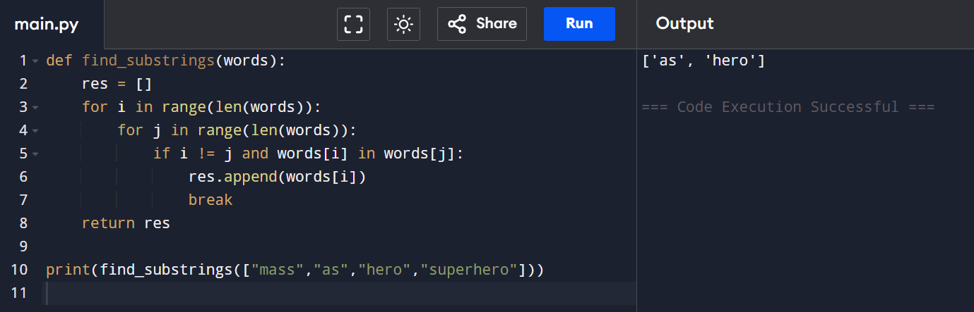

RESULT: All substring words are identified correctly.

EXP 9: Closest Pair of Points (Brute Force)

AIM: To find the closest pair of points in a set of 2D points using brute force.

CODE:

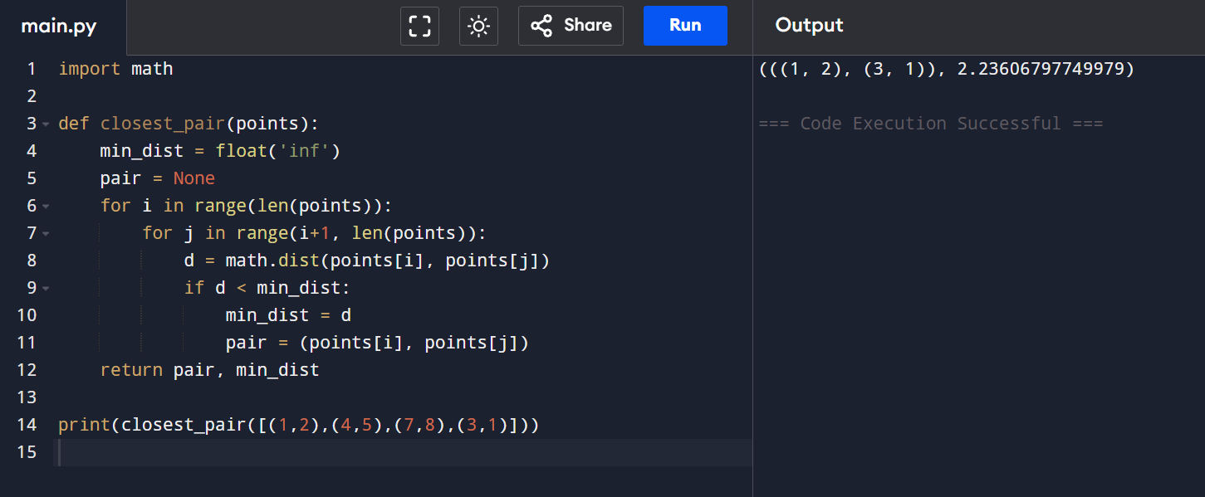

RESULT: The closest pair of points is found successfully using brute force.

EXP 10: Closest Pair & Convex Hull (Brute Force) with Analysis

AIM: To find the closest pair of points and convex hull using brute force and analyze time complexity.

CODE:

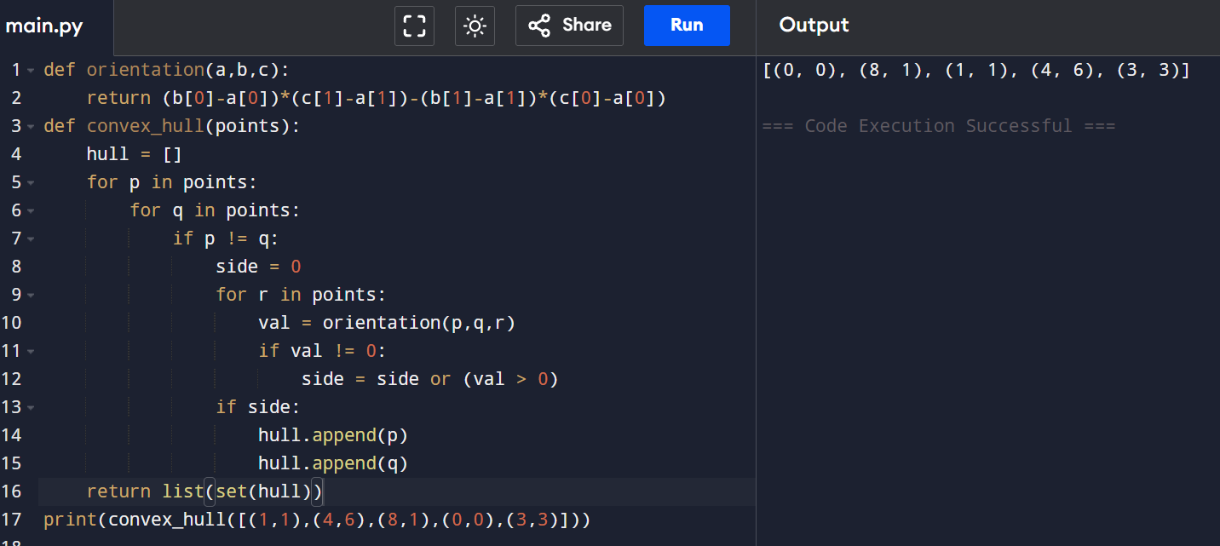
RESULT: Closest pair and convex hull are correctly identified.
Time Complexity: O(n²)

EXP 11: Convex Hull of 2D Points (Brute Force)

AIM: To find the convex hull of a given set of 2D points using brute force.

CODE:

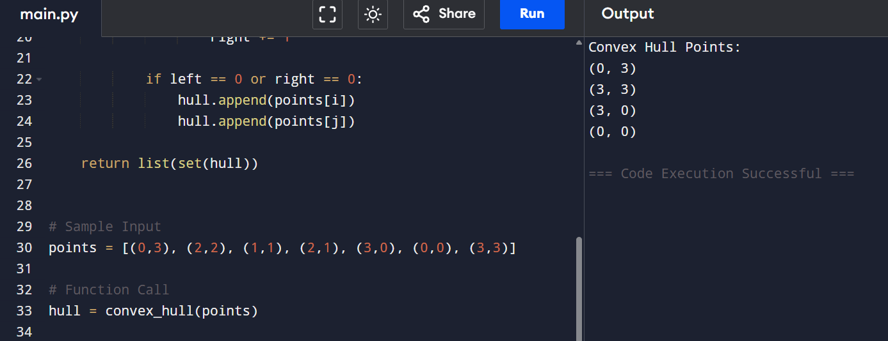

RESULT: The convex hull is obtained successfully.

EXP 12: Travelling Salesman Problem (Exhaustive Search)

AIM: To find the shortest possible route that visits all cities and returns to the start using exhaustive search.

CODE:

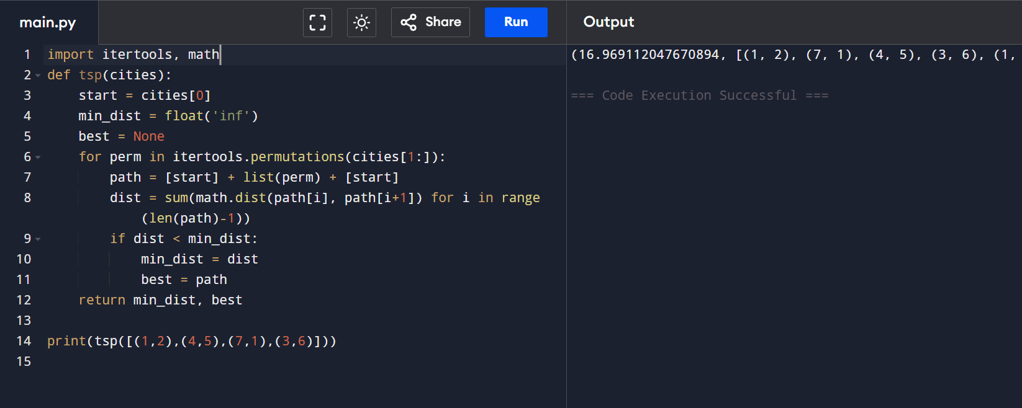

RESULT: The shortest route is identified correctly using exhaustive search.

EXP 13: Assignment Problem (Exhaustive Search)

AIM: To find the optimal worker-task assignment with minimum cost using exhaustive search.

CODE:

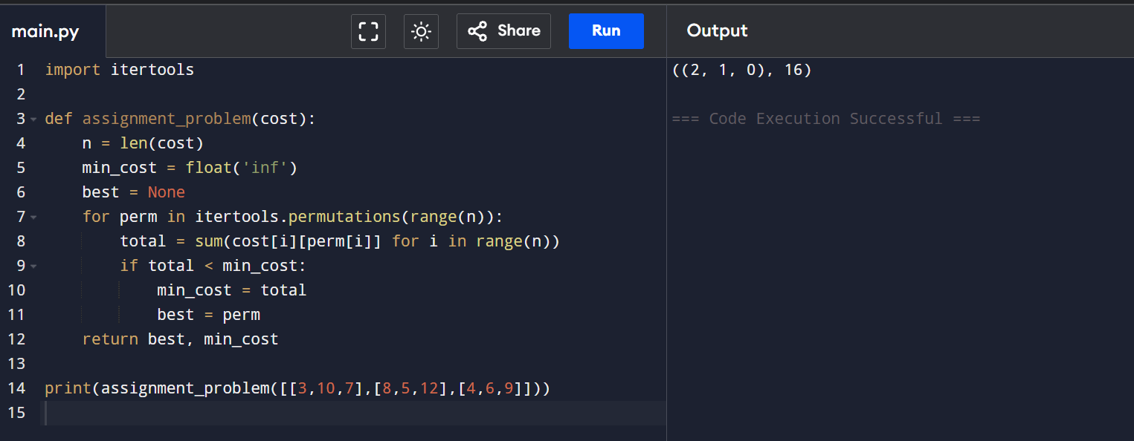

RESULT: The optimal assignment with minimum cost is obtained.

EXP 14: 0-1 Knapsack Problem (Exhaustive Search)

AIM: To select items that maximize total value without exceeding capacity using exhaustive search.

CODE:

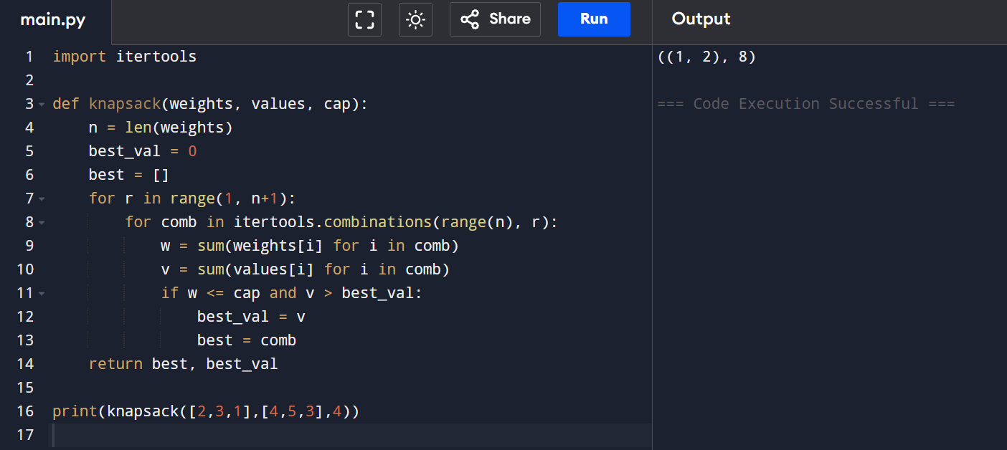

RESULT: The optimal item selection is found successfully.

